LAB-07 (TASKS)

Task-01:
class BankAccount {
String accountNumber;
String accountHolderName;
private double balance;

//Constructor
public BankAccount(String accountNumber, String accountHolderName, double balance){
this.accountNumber = accountNumber;
this.accountHolderName = accountHolderName;
this.balance = balance;
}

//Setter and Getter for balance (as private scope is limited to its own class)
//Can either use protected or public

protected void setBalance(double balance){
this.balance = balance;
}
protected double getBalance(){
return balance;
}

//Functions
public void deposit(double amount){
balance += amount;
}

public void withdraw(double amount){
if(amount > balance){
return;
}
balance -= amount;
}

public void displayAccount(){
System.out.println("====== Account Details ======");
System.out.println("Account no: " + accountNumber);
System.out.println("Holder name: " + accountHolderName);
System.out.println("Balance: " + balance);
System.out.println("=============================");
}
}

class SavingsAccount extends BankAccount {
private double interestRate; //annual interest

//Constructorclass BankAccount {
String accountNumber;
String accountHolderName;
private double balance;

//Constructor
public BankAccount(String accountNumber, String accountHolderName, double balance){
this.accountNumber = accountNumber;
this.accountHolderName = accountHolderName;
this.balance = balance;
}

//Setter and Getter for balance (as private scope is limited to its own class)
//Can either use protected or public

protected void setBalance(double balance){
this.balance = balance;
}
protected double getBalance(){
return balance;
}

//Functions
public void deposit(double amount){
balance += amount;
}

public void withdraw(double amount){
if(amount > balance){
return;
}
balance -= amount;
}

public void displayAccount(){
System.out.println("====== Account Details ======");
System.out.println("Account no: " + accountNumber);
System.out.println("Holder name: " + accountHolderName);
System.out.println("Balance: " + balance);
System.out.println("=============================");
}
}

class SavingsAccount extends BankAccount {
private double interestRate; //annual interest

//Constructor
public SavingsAccount(String accountNumber, String accountHolderName, double balance, double interestRate) {
super(accountNumber, accountHolderName, balance);
this.interestRate = interestRate;
}

//Function
public void calculateInterest(){
double interestEarned = (getBalance() * interestRate) / 100;
setBalance(getBalance() + interestEarned);
}

public void displayAccount() {
super.displayAccount();
System.out.println("Interest Rate: " + interestRate);
}
}
public class task1 {
public static void main(String[] args) {
SavingsAccount sa = new SavingsAccount("123", "Sherry", 5000.12, 0.05);

sa.deposit(1000);
sa.withdraw(3400.50);
sa.calculateInterest();
sa.displayAccount();
}
}

public SavingsAccount(String accountNumber, String accountHolderName, double balance, double interestRate) {
super(accountNumber, accountHolderName, balance);
this.interestRate = interestRate;
}

//Function
public void calculateInterest(){
double interestEarned = (getBalance() * interestRate) / 100;
setBalance(getBalance() + interestEarned);
}

public void displayAccount() {
super.displayAccount();
System.out.println("Interest Rate: " + interestRate);
}
}
public class task1 {
public static void main(String[] args) {
SavingsAccount sa = new SavingsAccount("123", "Sherry", 5000.12, 0.05);

sa.deposit(1000);
sa.withdraw(3400.50);
sa.calculateInterest();
sa.displayAccount();
}
}

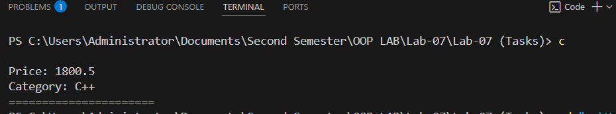
Output:
Task-02:
class Course {
protected String courseCode;
protected String courseName;
protected int courseCredits;

//public Course(){}
//I will use default constructor approach in main

public void setCourseCode(String x){
this.courseCode = x;
}

public void setCourseName(String y){
this.courseName = y;
}

public void setCourseCredits(int z){
this.courseCredits = z;
}
}

class UndergraduateCourse extends Course {
protected String departmentName;
protected int level; // 1 for freshman, 2 for sophomore,

//public UndergraduateCourse(){}

public void setDepartmentName(String dep){
this.departmentName = dep;
}

public void setLevel(int level){
this.level = level;
}
}

class Registration extends UndergraduateCourse {
// 'course' field kept only to satisfy task requirements
// but it's never really needed since Registration already IS a Course via inheritance
private Course course;
private int numStudents;
private int maxStudents;
private boolean isClosed;

public Registration(String courseCode, String courseName, int courseCredits, String departmentName,int level, Course course, int numStudents, int maxStudents, boolean isClosed){
//class Course
super.courseCode = courseCode; class Course {
protected String courseCode;
protected String courseName;
protected int courseCredits;

//public Course(){}
//I will use default constructor approach in main

public void setCourseCode(String x){
this.courseCode = x;
}

public void setCourseName(String y){
this.courseName = y;
}

public void setCourseCredits(int z){
this.courseCredits = z;
}
}

class UndergraduateCourse extends Course {
protected String departmentName;
protected int level; // 1 for freshman, 2 for sophomore,

//public UndergraduateCourse(){}

public void setDepartmentName(String dep){
this.departmentName = dep;
}

public void setLevel(int level){
this.level = level;
}
}

class Registration extends UndergraduateCourse {
// 'course' field kept only to satisfy task requirements
// but it's never really needed since Registration already IS a Course via inheritance
private Course course;
private int numStudents;
private int maxStudents;
private boolean isClosed;

public Registration(String courseCode, String courseName, int courseCredits, String departmentName,int level, Course course, int numStudents, int maxStudents, boolean isClosed){
//class Course
super.courseCode = courseCode;
super.courseName = courseName;
super.courseCredits = courseCredits;
//class UndergraduateCourse
super.departmentName = departmentName;
super.level = level;
//class Registration
this.course = course;
this.numStudents = numStudents;
this.maxStudents = maxStudents;
this.isClosed = isClosed;
}

public void setCourse(Course course){
this.course = course;
}

public void setNumStudents(int numStudents){
this.numStudents = numStudents;
}

public void setMaxStudents(int maxStudents){
this.maxStudents = maxStudents;
}

public void setIsClosed(boolean isClosed){
this.isClosed = isClosed;
}

public void registerStudent(){
if(isClosed){
System.out.println("Registration is closed!");
return; // exit early, no need for more checks
}
if(numStudents < maxStudents){
numStudents++;
System.out.println("Student registered!");
if(numStudents == maxStudents){
isClosed = true;
System.out.println("Course is now full. Registration closed.");
}
}
}

public void displayDetails(){
System.out.println("===== Course Details =====");
System.out.println("Code: " + courseCode);
System.out.println("Name: " + courseName);
System.out.println("Credits: " + courseCredits);
System.out.println("Department: " + departmentName);
System.out.println("No. of students: " + numStudents);
System.out.println("Max students: " + maxStudents);
if(isClosed){
System.out.println("Course is closed for registration.");
} else{
System.out.println("Course is open for registration.");
}
}
}

class task2 {
public static void main(String[] args) {
UndergraduateCourse OOP = new UndergraduateCourse();
Registration DLD = new Registration("EE-1005", "Digital Logic Design", 3, "SE", 1, OOP, 35, 50, false);

System.out.println("--- Before registrations ---");
DLD.displayDetails();

DLD.registerStudent();
DLD.registerStudent();

System.out.println("\n--- After registrations ---");
DLD.displayDetails();
}
}

super.courseName = courseName;
super.courseCredits = courseCredits;
//class UndergraduateCourse
super.departmentName = departmentName;
super.level = level;
//class Registration
this.course = course;
this.numStudents = numStudents;
this.maxStudents = maxStudents;
this.isClosed = isClosed;
}

public void setCourse(Course course){
this.course = course;
}

public void setNumStudents(int numStudents){
this.numStudents = numStudents;
}

public void setMaxStudents(int maxStudents){
this.maxStudents = maxStudents;
}

public void setIsClosed(boolean isClosed){
this.isClosed = isClosed;
}

public void registerStudent(){
if(isClosed){
System.out.println("Registration is closed!");
return; // exit early, no need for more checks
}
if(numStudents < maxStudents){
numStudents++;
System.out.println("Student registered!");
if(numStudents == maxStudents){
isClosed = true;
System.out.println("Course is now full. Registration closed.");
}
}
}

public void displayDetails(){
System.out.println("===== Course Details =====");
System.out.println("Code: " + courseCode);
System.out.println("Name: " + courseName);
System.out.println("Credits: " + courseCredits);
System.out.println("Department: " + departmentName);
System.out.println("No. of students: " + numStudents);
System.out.println("Max students: " + maxStudents);
if(isClosed){
System.out.println("Course is closed for registration.");
} else{
System.out.println("Course is open for registration.");
}
}
}

class task2 {
public static void main(String[] args) {
UndergraduateCourse OOP = new UndergraduateCourse();
Registration DLD = new Registration("EE-1005", "Digital Logic Design", 3, "SE", 1, OOP, 35, 50, false);

System.out.println("--- Before registrations ---");
DLD.displayDetails();

DLD.registerStudent();
DLD.registerStudent();

System.out.println("\n--- After registrations ---");
DLD.displayDetails();
}
}

Output:
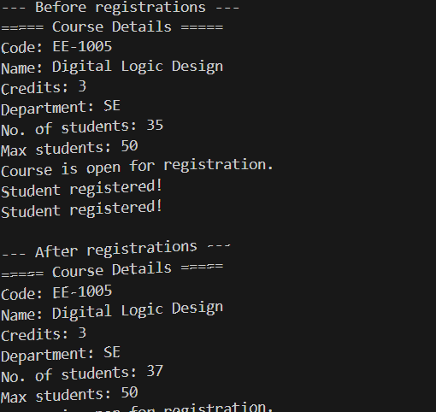

Task-03:
class Rectangle {
private double length;
private double breadth;

public Rectangle(double length, double breadth){
this.length = length;
this.breadth = breadth;
}

public void printArea(){
System.out.println("Area of Rectangle: " + (length * breadth));
}

public void printPerimeter(){
System.out.println("Perimeter of Rectangle: " + ((2*length)+(2*breadth)));
}
}

class Square extends Rectangle{
private double side; class Rectangle {
private double length;
private double breadth;

public Rectangle(double length, double breadth){
this.length = length;
this.breadth = breadth;
}

public void printArea(){
System.out.println("Area of Rectangle: " + (length * breadth));
}

public void printPerimeter(){
System.out.println("Perimeter of Rectangle: " + ((2*length)+(2*breadth)));
}
}

class Square extends Rectangle{
private double side;

public Square(double side){
super(side, side);
this.side = side;
}

public void printArea(){
System.out.println("Area of Square: " + (side*side));
}

public void printPerimeter(){
System.out.println("Perimeter of Square: " + (4*side));
}
}
class task3 {
public static void main(String[] args) {
Rectangle r = new Rectangle(10, 20);
r.printArea();
r.printPerimeter();

Square s = new Square(10);
s.printArea();
s.printPerimeter();
}
}

public Square(double side){
super(side, side);
this.side = side;
}

public void printArea(){
System.out.println("Area of Square: " + (side*side));
}

public void printPerimeter(){
System.out.println("Perimeter of Square: " + (4*side));
}
}
class task3 {
public static void main(String[] args) {
Rectangle r = new Rectangle(10, 20);
r.printArea();
r.printPerimeter();

Square s = new Square(10);
s.printArea();
s.printPerimeter();
}
}

Output:
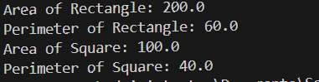

Task-04:
class Book {
protected int bookID;
protected String bookName;
protected String bookAuthor;
protected String ISBN;
protected double price;

public Book(int bookID, String bookName, String bookAuthor, String ISBN, double price) {
this.bookID = bookID;
this.bookName = bookName;
this.bookAuthor = bookAuthor;
this.ISBN = ISBN;
this.price = price;
}

public void displayDetails(){
System.out.println("==== Book Details ====");
System.out.println("Id: " + bookID);
System.out.println("Name: " + bookName);
System.out.println("Author: " + bookAuthor);
System.out.println("ISBN: " + ISBN);
System.out.println("Price: " + price);
}
}

class Category1 extends Book {
protected String category;

public Category1(int bookID, String bookName, String bookAuthor, String ISBN, double price, String category){
super(bookID, bookName, bookAuthor, ISBN, price);
this.category = category;
}

public void displayDetails() {
super.displayDetails();
System.out.println("Category: " + category);
System.out.println("======================");
}
}

class task4 {
public static void main(String[] args) {
// Upcasting: child object stored in parent reference
Book b1 = new Category1(101, "Let Us C", "idk", "978-8183331630", 1200.99 class Book {
protected int bookID;
protected String bookName;
protected String bookAuthor;
protected String ISBN;
protected double price;

public Book(int bookID, String bookName, String bookAuthor, String ISBN, double price) {
this.bookID = bookID;
this.bookName = bookName;
this.bookAuthor = bookAuthor;
this.ISBN = ISBN;
this.price = price;
}

public void displayDetails(){
System.out.println("==== Book Details ====");
System.out.println("Id: " + bookID);
System.out.println("Name: " + bookName);
System.out.println("Author: " + bookAuthor);
System.out.println("ISBN: " + ISBN);
System.out.println("Price: " + price);
}
}

class Category1 extends Book {
protected String category;

public Category1(int bookID, String bookName, String bookAuthor, String ISBN, double price, String category){
super(bookID, bookName, bookAuthor, ISBN, price);
this.category = category;
}

public void displayDetails() {
super.displayDetails();
System.out.println("Category: " + category);
System.out.println("======================");
}
}

class task4 {
public static void main(String[] args) {
// Upcasting: child object stored in parent reference
Book b1 = new Category1(101, "Let Us C", "idk", "978-8183331630", 1200.99, "C");
Book b2 = new Category1(102, "Head First Java", "idk", "978-0596009205", 1500.00, "Java");
Book b3 = new Category1(103, "C++ Primer", "idk", "978-0321714114", 1800.50, "C++");

b1.displayDetails();
b2.displayDetails();
b3.displayDetails();
}
}

, "C");
Book b2 = new Category1(102, "Head First Java", "idk", "978-0596009205", 1500.00, "Java");
Book b3 = new Category1(103, "C++ Primer", "idk", "978-0321714114", 1800.50, "C++");

b1.displayDetails();
b2.displayDetails();
b3.displayDetails();
}
}

Output:
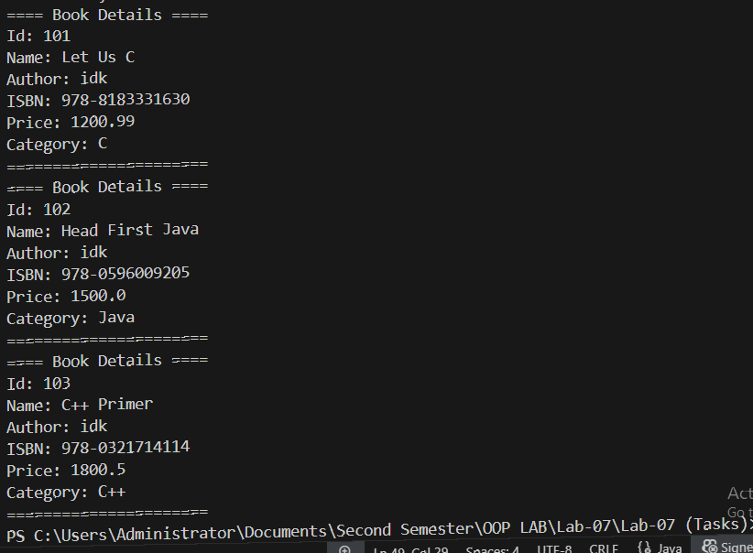

Task-05:
class Vehicle {
private int speed;
private String colour;
private int numWheels;

public Vehicle() {
this.speed = 0;
this.colour = "None";
this.numWheels = 0;
}

public Vehicle(int speed, String colour, int numWheels) {
this.speed = speed;
this.colour = colour;
this.numWheels = numWheels;
}

public void setSpeed(int speed){
this.speed = speed;
}

public void setColour(String colour){
this.colour = colour;
}

public void setNumWheels(int numWheels){
this.numWheels = numWheels;
}

public int getSpeed(){
return speed;
}

public String getColour(){
return colour;
}

public int getNumWheels(){
return numWheels;
}
}

class MotorVehicle extends Vehicle {
private String licensePlate;

public MotorVehicle(){
super();
this.licensePlate = "";
}

public void setLicensePlate(String licensePlate){
this.licensePlate = licensePlate;
}

public String getLicensePlate(){
return licensePlate;
}
}

class Car extends MotorVehicle {
private int numDoors;

public Car(){
super(); // calls MotorVehicle() → which calls Vehicle()
this.numDoors = 0;
}

public void setNumDoors(int numDoors){
this.numDoors = numDoors;
}

public int getNumDoors(){
return numDoors;
}

public void display(){
System.out.println("===== Vehicle Details =====");
System.out.println("Speed: " + getSpeed());
System.out.println("Colour: " + getColour());
System.out.println("No. of wheels: " + getNumWheels());
System.out.println("License plate: " + getLicensePlate());
System.out.println("No. of doors: " + numDoors);
}
}

class task5 {
public static void main(String[] args) {
Car car = new Car();
car.setSpeed(120);
car.setColour("Red"); class Vehicle {
private int speed;
private String colour;
private int numWheels;

public Vehicle() {
this.speed = 0;
this.colour = "None";
this.numWheels = 0;
}

public Vehicle(int speed, String colour, int numWheels) {
this.speed = speed;
this.colour = colour;
this.numWheels = numWheels;
}

public void setSpeed(int speed){
this.speed = speed;
}

public void setColour(String colour){
this.colour = colour;
}

public void setNumWheels(int numWheels){
this.numWheels = numWheels;
}

public int getSpeed(){
return speed;
}

public String getColour(){
return colour;
}

public int getNumWheels(){
return numWheels;
}
}

class MotorVehicle extends Vehicle {
private String licensePlate;

public MotorVehicle(){
super();
this.licensePlate = "";
}

public void setLicensePlate(String licensePlate){
this.licensePlate = licensePlate;
}

public String getLicensePlate(){
return licensePlate;
}
}

class Car extends MotorVehicle {
private int numDoors;

public Car(){
super(); // calls MotorVehicle() → which calls Vehicle()
this.numDoors = 0;
}

public void setNumDoors(int numDoors){
this.numDoors = numDoors;
}

public int getNumDoors(){
return numDoors;
}

public void display(){
System.out.println("===== Vehicle Details =====");
System.out.println("Speed: " + getSpeed());
System.out.println("Colour: " + getColour());
System.out.println("No. of wheels: " + getNumWheels());
System.out.println("License plate: " + getLicensePlate());
System.out.println("No. of doors: " + numDoors);
}
}

class task5 {
public static void main(String[] args) {
Car car = new Car();
car.setSpeed(120);
car.setColour("Red");
car.setNumWheels(4);
car.setLicensePlate("ABC-1234");
car.setNumDoors(4);

car.display();
}
}

car.setNumWheels(4);
car.setLicensePlate("ABC-1234");
car.setNumDoors(4);

car.display();
}
}

Output:
